Formation of Fossil Molds and Casts
Original lab by Mrs. Kaitlyn McClintock, Hanover Area School District, 2008
Name _______________________________ Date _________________

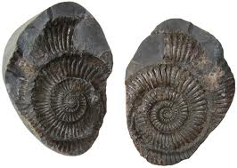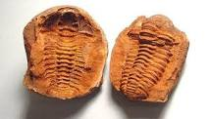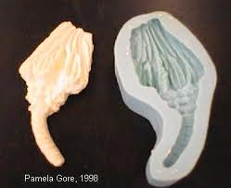
Ammonite Mold and Cast Trilobite Mold and Cast Unknown Cast and Mold
Purpose: In this lab activity, you will demonstrate how fossil molds and fossil casts are formed.
Materials: ½ cup of plaster of Paris per student or group, sea shell, ½ stick of modeling clay per
student or group, empty 8 oz. cup, 1 plastic spoon, school glue, 2 rubber bands, wooden
popsicle stick, paper or plastic plate

Safety: Wear goggles and gloves with plaster of Paris, or just do clay/Play Doh portion of lab. Wash hands with soap for twenty seconds at end of activity.

Procedures: Day One…
1. Take the piece of clay and divide it into two equal pieces. Flatten each piece like a pancake.
2. Choose a sea shell “fossil.”
3. Place the fossil between both pieces of clay and press down firmly from the top. As this is done, the
sea shell will make deep impressions in the clay.
4. Pull the two pieces of clay apart and retrieve the sea shell.
5. Fill in the information in Part A of the Data-Analysis section of the lab.
6. Pour about half of your plaster of Paris into the empty cup. Add tap water slowly, while mixing with
the spoon, until the mixture is the consistency of pancake batter {smooth (no lumps)
and medium in thickness}. You may need to add more plaster of Paris to achieve a workable
consistency. It should be able to flow into the fossil molds.
7. Pour the plaster of Paris mixture into both fossil molds that you have previously made. Fill each until
they are level with the top of the clay. Use a popsicle stick to smooth the surface of the plaster of
Paris.
8. Place your clay samples on the plate in a designated area and allow to dry until the next day. Make
sure your initials are in the clay or on the plate.
Day Two…
9. Retrieve your clay.
10. Carefully remove the hardened plaster of Paris from the clay. Cut off any jagged edges from the
sides of both pieces.
11. Glue the two pieces together in the center; you may need to wrap a few rubber bands around them
to hold in place to dry.
12. Examine your hardened plaster of Paris model, and fill in the information in Part B of the
Data-Analysis section.
Data-Analysis Section:
Part A
1. After you removed the plaster of Paris sea shell from the clay, the deep impressions left
behind in the clay are examples of fossil ______________________.
2. In the boxes below, make sketches of both of your clay samples.
Top half of clay Bottom half of clay

3. Upon examination of both the top and bottom impressions in the clay, are they close to an exact
replica of the original fossil model you pushed into the clay? _________
4. In nature, what originally happens to the real bone, tooth, or sea shell that has been buried in
sediments? _____________________________________________________________________
5. What happens to the sediments over time? ___________________________________________
________________________________________________________________________________
6. Would all body parts fossilize? ____________
7. Explain your answer to # 7 and give a few examples.
________________________________________________________________________________
________________________________________________________________________________
________________________________________________________________________________

Part B
8. The two pieces of plaster of Paris that you glued together represent what type of fossil commonly
found in fossil beds? ________________________
9. In the boxes below, make two sketches. One sketch is of the original fossil model, while the other is
your plaster cast.
Fossil Model Plaster of Paris cast

10. How closely does your plaster of Paris cast match the original fossil you used?
___________________________________________________________________________
11. Using the information obtained while doing this lab, explain how fossil molds and casts form in
nature. You may also use the Internet or reference books for help with your answer.
A. Fossil molds : ___________________________________________________________________
_______________________________________________________________________________
_______________________________________________________________________________
_______________________________________________________________________________
_______________________________________________________________________________
B. Fossil casts: ____________________________________________________________________
______________________________________________________________________________
______________________________________________________________________________
_______________________________________________________________________________
_______________________________________________________________________________

