HUMAN GENETICS TRAITS LAB
Objective: To observe different human genetics traits, find the frequency of occurrence
among class members, and write genotypes for each trait.
Vocabulary: DNA – The chemical that provides the hereditary information or blueprint for the
traits of all living things.
Gene – A piece (sequence) of DNA that carries the information for one trait, like
Tongue roller.
Allele – One form (letter) of a gene, like T or t.
Phenotype - The appearance of a genetic trait like Tongue Roller or Nonroller.
Genotype - The genetic make-up (letters) of a trait, like TT, Tt, or tt.
Dominant – A trait that is stronger, or masks the appearance of a recessive trait if
both genes are present together, like Roller over Nonroller.
Recessive – A trait that is weaker, or hidden by the presence of a dominant trait,
like Nonroller.
Incomplete Dominance: When both traits are equal, or neither trait is dominant; an
intermediate trait or mixture is seen.

Pure Bred – When both letters (alleles) are the same for a trait, like TT or tt.
Hybrid – When both letters (alleles) are different for a trait, like Tt.
Hypothesis: Do you predict the number of class members having each Dominant trait as compared to

Recessive traits will be greater, equal, or the lesser in number? ___________________
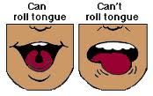 TONGUE ROLLER (DOMINANT)
1. (Phenotype) Can you roll your tongue? __________________
Class results: *Genotypes are often expressed with the capital first letter for the dominant
trait, like R for roller.
Phenotypes: | Roller | Nonroller
Class Total: # of each group:
Possible Genotypes: | or

SODIUM BENZOATE TASTING (DOMINANT) (*If test paper available)
2. A. First try to taste the Control paper. Can you taste any chemical on the paper? ______ Describe
what you taste: ________________________________________________________________________
B. (Phenotype) Next try to taste the Sodium Benzoate paper. Does this taste different than the
Control paper? _________ If different, describe what you taste _______________________
____________________________________________________________________________

Phenotypes: | Taster | Nontaster
Class Total: # of each group:
Possible Genotypes: | or

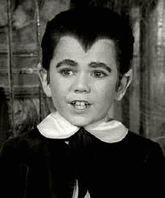 WIDOW’S PEAK (DOMINANT)
3. (Phenotype) Do you have a widow’s peak? _________
Phenotypes: | Peak | No Peak
Class Total: # of each group:

Possible Genotypes: | or

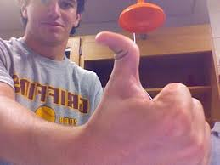 HITCHHIKER’S THUMB (RECESSIVE)
4. (Phenotype) Do you have a hitchhiker’s thumb? ___________
Phenotypes: | Hitchhiker’s Thumb | Straight Thumb
Class Total: # of each group:
Possible Genotypes: | or

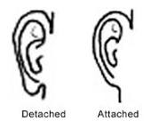 EARLOBES (DETACHED OR UNATTACHED DOMINANT)
5. (Phenotype) Do you have unattached or attached earlobes? ___________________
Phenotypes: | (Detached) Unattached Earlobe | Attached Earlobe
Class Total: # of each group:
Possible Genotypes: | or

EYECOLOR (BROWN/HAZEL DOMINANT OVER BLUE/GREEN/GRAY)
6. (Phenotype) What color eyes do you have? _____________________
Phenotypes: | Brown/Hazel Eye Color | Blue/Green/Gray Eye Color
Class Total: # of each group:
Possible Genotypes: | or

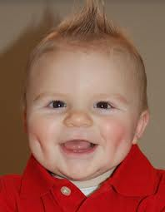 DIMPLES (DOMINANT)
7. (Phenotype) Do you have one or more dimples? __________
Phenotypes: | Dimple(s) | No Dimple(s)
Class Total: # of each group:
Possible Genotypes: | or

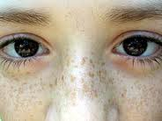 FRECKLES (DOMINANT)
8. (Phenotype) Do you have freckles? ______________
Phenotypes: | Freckles | No Freckles
Class Total: # of each group:
Possible Genotypes: | or

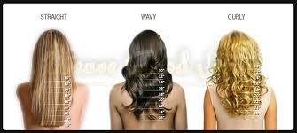 STRAIGHT/WAVY/CURLY HAIR (INCOMPLETE DOMINANCE)
9. (Phenotype) Do you have straight, wavy, or curly hair? __________________
*Genotypes for a trait with incomplete dominance are sometimes expressed with a different capital
letter for each trait, so SS (straight), CC curly, or SC (wavy) hair.
Phenotypes: | Straight | Wavy | Curly
Class Total: # of each group:
Possible Genotypes:

Analysis: 1. Look at the Class results and fill in the following chart:
Trait | # Class members Dominant | # Class Members Recessive
1. Tongue Rolling
2. Sodium Benzoate
3. Widow’s Peak
4. Hitchhiker’s Thumb
5. Earlobes
6. Eyecolor
7. Dimples
8. Freckles
2. For how many traits did the Dominant choice have a greater number than the Recessive choice?
______________________
3. For how many traits did the Recessive choice have a greater number than the Dominant choice?
______________________
4. Which traits had a higher number more often, Dominant or Recessive? ______________________
5. Was your original Hypothesis correct or incorrect? ____________________________
6. Summary: Using complete sentences, write three facts or concepts you have learned from this
experiment.
- ______________________________________________________________________________
_______________________________________________________________________________
- ______________________________________________________________________________
_______________________________________________________________________________
- ______________________________________________________________________________

______________________________________________________________________________

7. Extra Credit: Research on the Internet or in a science book why sometimes Dominant traits might
have a lower number than expected as compared to Recessive traits in an individual
classroom study. Explain the answer you found below in your own words. You might
also try to come up with a reasonable idea on your own, but it should be well-explained.

