Feb. 23, 2009
Olympia, WA

The Brain-considerate Math and Science Classroom:
Making Connections

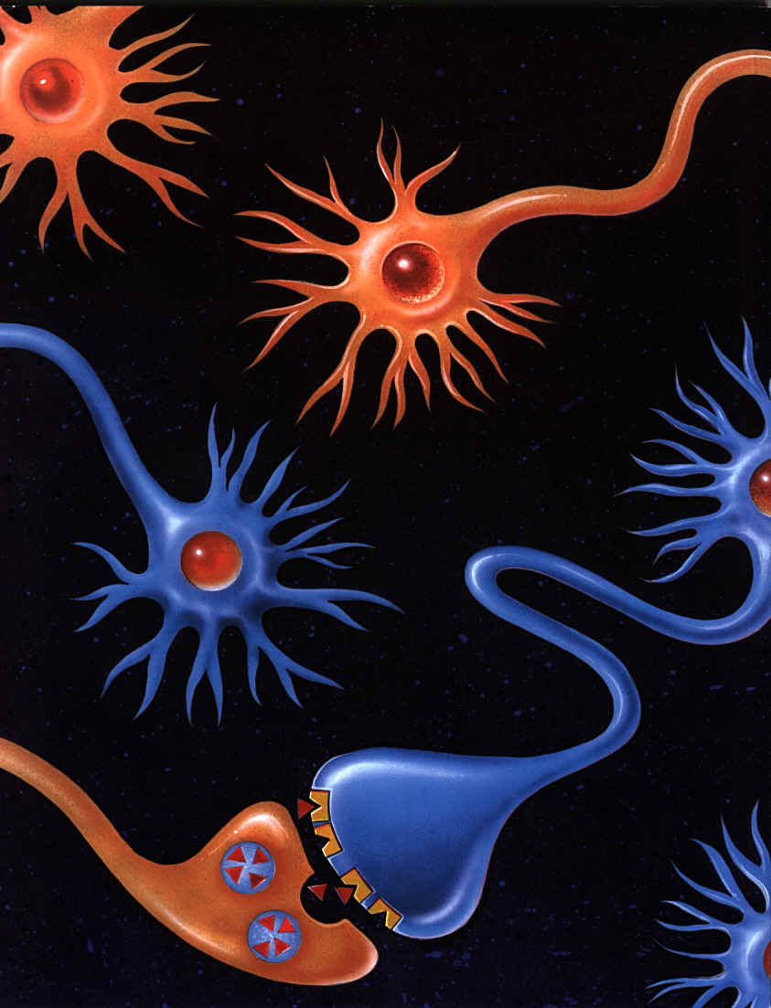

Kenneth Wesson

Educational Consultant: Neuroscience
1497 Elsman Ct.
San Jose, CA 95120
(408) 323-1498 (office)
kenawesson@aol.com

The Law of Effect
Edward Thorndike

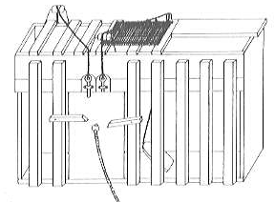
Some of the major contributions to the field of Psychology came from American psychologist Edward Thorndike’s (1874 - 1949) studies with animals. While Pavlov was coaxing dogs to salivate simultaneously with the ringing of a bell in St. Petersburg, Russia, Thorndike’s was clawing his way to the fame. His extensive research was centered on instrumental conditioning, where he placed cats into specially constructed "puzzle boxes." During this learning process, an animal makes a behavioral response to a stimulus or situation, and if that behavior is rewarded, the response gets increasingly associated with the stimulus and is considered learned. If the behavior or response is not rewarded, that behavior is seen less and less or is not repeated at all. Those behaviors gradually disappear.

Thorndike’s puzzle boxes were small cages from which an animal could only escape by making a specific behavioral response. In this case (pictured above), there was a door that a cat could open by pulling a loop of string, after which time the cat would receive a reward (fresh fish). Thorndike showed that a cat could learn to pull the string, escape from the cage, and eat the fish that was placed just outside of the cage.

When cats were placed into the puzzle box, they immediately tried to escape to eat the fish. They tried to squeeze through any opening; they clawed and bit at the bars; they thrust their paws out through all reachable openings and clawed at anything within reach. By accident, the cat would eventually claw the loop of string and the door would open. Subsequently, each time the cat was placed back into the puzzle box, he got out faster. The act of pulling the string occurred sooner with each trial until eventually the cat ran to the string and pulled it the moment he was placed into the box without much delay.

The animal’s learning curve was demonstrated by the length of time the cat spent in the box on successive trials before pulling the loop. The amount of time decreased with each successive trial. The connection between the cat's situation and the response that freed him was “stamped in.” Thorndike coined the term the “Law of Effect,” which describes how stimuli and responses become either connected or dissociated from one other based on learned consequences. The final interpretation of the law of effect was that the immediate consequence of a mental connection would either strengthen the learned connection or extinguish it.

However, the key question Thorndike wanted to answer was: Just how did the cat learn? Thorndike recognized that it was almost as important to show how cats did not learn. He showed that having a teacher did not help. Cats did not learn by imitation. Repeatedly watching another cat that had already learned how to get out of the box was of no help at all. Thorndike also showed that cats did not learn by demonstration. (He physically took the cat’s paw and pulled the string with it so that cat could get out.) But, after many such demonstrations, if the cat was then left alone in the box, it did not immediately pull the loop. The cat still needed to make the discovery and the association by himself.

Thorndike concluded that the cat could learn to get out of the box only by investigating on his own and learning first-hand by the process of trial-and-error. It is through this same process that all mammals, including human beings, discover which of our actions produce a desired outcome. We call that active process learning.

This evaluation of mammalian learning led Thorndike to conclude that animals learn primarily by trial and error, and/or by reward and punishment. Thorndike used the cat's behavior in the puzzle box to describe what happens when all organisms learn. Learning involves the formation of neural connections, and these connections are strengthened according to the law of effect. Intelligence, ultimately, is the ability to form connections. Humans are the most evolved animals and we form more connections then any other organism.

The Natural Progression of Concept Development

If I Can… Then I am Able To…
Experience a concept first-hand Discuss it orally
(“Hands-on, minds-on, hearts-in learning”)

Discuss it orally Understand what others mean, when they talk about it

Understand when I discuss it and Communicate it in written form
when and others discuss it

Communicate it in written form Read my own writing

Do it, see it, discuss it, hear about it Explain it to others intelligently
and write about it

Explain it to others Read the writing of others on the same subject

Understand the descriptive writings Begin reading (the writing of others) in the
of others on the subject broader content area

Read factual and content-area writing Connect the concept to other disciplines

Connect it to diverse disciplines Comprehend fictional writing within the subject area

Process the concept on both a literal and Connect it to relevant abstractions
a fictional level

Connect it to abstractions Begin thinking of the concept on a global scale and/or in a creative context

Think of the concept on a global and/or Ask “connecting” questions, “what if,”
a creative level as well as philosophical questions (at the higher cognitive levels). The very best indicator for determining how well an individual truly knows a concept is not the answers he gives, but by the cognitive level of the questions that he begins to ask.
Excerpted from Memory and the Brain: How Teaching Leads to Learning. The Independent School, Volume 63, Spring 2002

Kenneth Wesson kenawesson@aol.com (408) 323-1498

Brain-considerate Learning: “PERC³S”

The human brain has developed with specialized techniques to simplify its work. Once wired properly, there are several Brain-considerate strategies for organizing, learning, and remembering information. The human brain has an innate predisposition to recognize patterns that are relevant to our existence, in contexts that are personally and emotionally significant in ways that make sense to us. The human brain processes data looking for (1) Patterns, (2) Emotions, (3) Relevance, (4) Context, Content, and Cognitively-appropriate, and (5) Sense-making or “PERCS.” Most importantly, the brain is a biological organ that survived the eons by anticipating and using these criteria to learn and survive in whatever environment it might finds itself.
As learning occurs, the human brain methodically encodes the most accurate representations of the surrounding world that it possible can. All incoming information is meticulously dissected and filtered based on prior knowledge/experience and distributed to specialized regions of the human brain (localized for explicit functions) where it is processed, stored and subsequently utilized when similar environmental stimuli present themselves. Memories are easier to retrieve or recall when they are linked to well-established skills or information that is linked to existing cognitive circuitry.
A healthy brain is capable of retrieving and utilizing vast amounts of stored information, as well as mentally manipulating images (elements housed on the same neural circuits initially deployed in the formation of those images/representations) for future actions. The human brain does not reproduce events exactly as they occurred comparable to a video recorder. Instead, it re-assembles the constituent memory elements as honest (often incorrect) approximations to the original event. Accuracy is a casualty of time.
Understanding the methodologies of brain processing will help educators in crafting corresponding instructional practices and classroom environments that (a) are consistent with the brain’s natural inclinations for thinking and learning, and (b) improve cognition and academic success for all students.

1. Patterns aid in concept development, understanding and memory retrieval.
- How do the conceptual pieces “fit together” in a rational manner that provides me with a viable explanation of the facts, objects or the events that are unfolding in front of me?
b. Can I envision relationships and connections that allow me to make predictions?
c. Am I able to construct internal models using patterns to represent my natural surroundings?
2. Emotions: The emotional significance of an event shapes one's subsequent responses. Fear/ distress
inhibit concept learning and retrieval.
a. Does this have personal importance to me? (Motivation) If not, then I will disengage.
b. Does this object, fact or occurrence have any personal or “emotional currency”? (Interest)
c. Is my amygdala engaged and has my hippocampus been activated to remember this event?
3. Relevance determines whether paying attention is warranted (irrelevant = ignored). Memories are easier to
retrieve when connected to frequently used, well-established, existing cortical circuitry.
a. Is there an implicit or explicit connection to my life or personal goals?
b. Are there similar or related events, ideas stored on my existing neural pathways?
4. C³ = Context, Content, and Cognitively-appropriate: Learning requires context. Decontextualized trivia
seldom reaches permanent (LT) memory
- Is the target information presented in a “frame” that is realistic, coherent, or effortlessly memorable to the learner? Can it be connected to a personally recognizable/meaningful situation? Is there a contextual “bridge” (existing neural connections) from what I already know to this “new” information?
- Is the content (knowledge at stake) interesting? Is this the most effective methodology for its delivery?
- Is the information cognitively accessible/developmentally-appropriate? Is it within the learner’s “Zone of Proximal Development”? Is it presented in complex abstractions beyond the learner’s experiential background or cognitive processing abilities?
5. Sense-making: We are instinctively driven to make sense out of our sensory perceptions.
- Does new data mesh with previously validated/personally confirmed information?
- Am I uncertain about the logic behind this information or experience?
c. Am I able to rectify discrepant data, erroneous preconceptions or misconceptions?

Kenneth Wesson kenawesson@aol.com (408) 323-1498

Science Teachers Guide and Facilitate Learning

By doing so, teachers
- Focus and support inquiries while interacting with students (the “guide on the side”)
- Orchestrate discourse among students about scientific ideas (“accountable talk”).
- Challenge students to accept and share responsibility for their own learning.
- Recognize and respond to student diversity by encouraging all students to participate in science learning (Learning styles; Multiple Intelligences.)
- Encourage and model the skills of scientific inquiry, as well as the curiosity, openness to new ideas and data, and skepticism that characterize science.

"Scientific inquiry refers to the diverse ways in which scientists study the natural world and propose explanations based on the evidence derived from their work. Inquiry also refers to the activities of students in which they develop knowledge and understanding of scientific ideas, as well as an understanding of how scientists study the natural world."

-- National Science Education Standards: Teaching Standard B

What Kinds of Questions Should I Ask to Facilitate Inquiry?
- Questions are at the heart of inquiry-based teaching and learning.
- While questions have often been part of the traditional classroom, the sources and purposes of inquiry-based questions are quite different.
- In traditional classrooms: Teachers use questions to promote feedback.
- In the inquiry classroom, a teacher asks questions that are more open-ended, connecting questions and questions that are reflective in their nature
- "What are you thinking, and why do you think that?
- "What do you notice here?”
- “What does it make you wonder now related to the….?”
- "How is this helping us to understand this idea better, as young developing scientists?")
- Have students draw, write, and record information as they use their notebooks or folders, where they will document their findings, questions and experiences for reviewing, re-thinking and revising later. Teachers should also document:
- What the students were doing
- What they were saying
- What they were thinking
- What questions were the students asking
- What the students discovered out, and other ways that students found their answers.

Kenneth Wesson kenawesson@aol.com (408) 323-1498

Brain-Considerate Classrooms

Kenneth Wesson
Educational Consultant: Neuroscience

1. Students need frequent personal acknowledgement and public acceptance (the “seeds of hope”) before, during and after learning activities. They all need individual recognition in a friendly and supportive learning environment (a “community of learners,” including the teacher).

2. Learning must offer developmentally-appropriate challenges, and opportunities for problem solving, personal growth, a sense of achievement and a recognizable end point.

3. Clearly stated learning and behavioral expectations with
achievable, tangible and measurable goals understood by the learner (providing a sense of empowerment).

4. “Connected” learning experiences, concepts, themes, activities, social/personal interactions, etc. (enhancing neural circuitry) with a rich usage of sensory stimulation.

5. A non-threatening/non-punitive learning environment. Errors are not permanent/nor are they personal indictments. Instead, they present identifiable opportunities for sculpting one's “emerging talents.” Unlike medieval torture chambers, classrooms should not have “victims.”

6. Regular performance feedback: “Mental” dropouts (doing “seat time”) result from seldom knowing whether they are succeeding or not (or if instructional methods need modification.)

7. Let questions “sit there” (“auto-ponder” -- metacognition) prompting multiple answers.

8. Positive “emotional responses” --There is no room for “put-downs” in the classroom. (Computers: “Garbage in, garbage out.” The brain: “Garbage in. It often remains in for a lifetime” as a permanently based self-defeating critic.)

9. Stimulate all of the senses. Elaborate neural connectivity results from a rich variety of experiences. Infuse art, dance, music, drama and movement into learning whenever possible.

10. Acknowledge diversity as well as “proversity” (the multitude of ways in which we are all alike or identical). All brains are basically gray. Only gray matter matters in neuroscience.

11. Offer a range of assessment options (formats, modalities, formality, times, places, etc.)

12. Allow “downtime” for students to “reflect and connect” on their knowledge.

13. Draw and write often! One cannot write without thinking. One cannot draw without thinking. One cannot solve problems without thinking. (“Drawing does for the brain during the day, what dreaming does for the brain at night.”)
14. While students initially will notice your physical attributes, a teacher’s attitude is equally conspicuous. It impacts learning from the moment it is processed consciously or subconsciously. A teacher’s disposition in the classroom can be a significant point on the way to learning or in the way of learning.

15. Learners should be encouraged to ask questions and explore (not just “allowed” to ask questions and explore.)

Kenneth Wesson kenawesson@aol.com (408) 323-1498

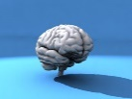
Terminology for Contemporary Educators

Automaticity – Benjamin Bloom: The ability to proficiently perform a task unconsciously,
while carrying out another task simultaneously.
Behaviorism – B.F. Skinner: The theory of behavior/learning that is based on observable
changes in behavior as a response to a stimulus.
Brain-Considerate Learning – Kenneth Wesson: Using the current research from the
cognitive neurosciences to plan instruction and student learning based on how human beings process and store information.
Cognitivism - David Ausubel: How humans perceive, learn, remember, and think about
information. Learning is a mental process occuring inside a learner, which can be understood by quantitative and scientific methods using information processing models.
Constructivist Learning Theory – Jerome Bruner/Jean Piaget: Learners construct
knowledge for themselves, where each learner individually and socially constructs personal meaning while he or she learns.
Contextual Learning: Educators should relate content information in the classroom to
real world situations and encourage students to seek connections between internal knowledge and external applications.
Developmentally Appropriate Learning: Using our knowledge of child development to plan
learning activities and materials within the range of appropriate expectations based on the specific age of the learners.
Differentiated Learning: Deploying instructional strategies that exploit a wide using a
variety of teaching techniques to address the diverse learning needs of students.
Flexibility in Thinking – Ed de Bono: Developing in students the “problem-solving
repertoire” that equips them with the cognitive flexibility to explore and find
multiple resolutions for a single problem.
Hemispherisity – Roger Sperry: The concept that individuals rely on either the left or
right cerebral hemisphere for their preferred mode of neural processing.
Multiple Intelligences – Howard Gardner: Nine cognitive/performance faculties in which one
develops proficiency (Verbal-Linguistic, Mathematical-Logical, Musical, Visual-Spatial, Bodily-Kinesthetic, Interpersonal, Intrapersonal, Naturalist, and Existential Intelligence)
Neural Plasticity – Marian Diamond and Mark Rosenzweig: Physical changes occur in
the brain as a consequence of learning, experience and memory.
Outcomes-Based Education – Bill Spady: Learning objectives are driven by the
outcome displayed by the learner at the culmination of the educational experience.
Research-based: Educational programs that are grounded in research from the cognitive
neurosciences vs. those developed around contemporary market research.
Self-appropriated Learning – Carl Rogers: Permanent knowledge that a learner acquires
through personal experiences and self-monitoring.
Situated learning –Jean Lave/Etienne Wenger: Learning is best when it that takes place in
a setting that functionally identical to that where the learning will later be applied.
Theory of Cognitive Development – Jean Piaget: Children proceed through a
predictable series of stages during their intellectual development.
Zones of Proximal Development – Lev Vygotsky: The area of cognitive development in which
students can learn the learner’s ability range.

Kenneth Wesson kenawesson@aol.com (408) 323-1498

