Affect Versus Effect
When to use affect and effect is one of the most common questions I get. This is an expanded show based on the original episode covering when to use affect with an a and when to use effect with an e.
By
Mignon Fogarty,
Grammar Girl
July 29, 2008

- See more at: http://www.quickanddirtytips.com/education/grammar/affect-versus-effect?page=all#sthash.33x0ncQ4.dpuf

Episode #121
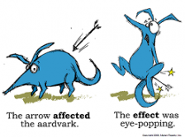I get asked whether to use affect or effect all the time, and it is by far the most requested grammar topic, so I have a few mnemonics and a cartoon to help you remember.

What Is the Difference Between Affect and Effect?
Before we get to the memory trick though, I want to explain the difference between the two words: The majority of the time you use affect with an a as a verb and effect with an e as a noun.

When Should You Use Affect?
Affect with an a means "to influence," as in, "The arrows affected Aardvark," or "The rain affected Amy's hairdo." Affect can also mean, roughly, "to act in a way that you don't feel," as in, "She affected an air of superiority."

When Should You Use Effect?
Effect with an e has a lot of subtle meanings as a noun, but to me the meaning "a result" seems to be at the core of all the definitions. For example, you can say, "The effect was eye-popping," or "The sound effects were amazing," or "The rain had no effect on Amy's hairdo."

Common Uses of Affect and Effect
Most of the time, affect is a verb and effect is a noun.
There are rare instances where the roles are switched, and I'll get to those later, but for now let's focus on the common meanings. This is "Quick and Dirty" grammar, and my impression from your questions is that most people have trouble remembering the basic rules of when to use these words, so if you stick with those, you'll be right 95% of the time.
So, most of the time, affect with an a is a verb and effect with an e is a noun; and now we can get to the mnemonics. First, the mnemonic involves a very easy noun to help you remember: aardvark. Yes, if you can remember aardvark—a very easy noun—you'll always remember that affect with an a is a verb and effect with an e is a noun. Why? Because the first letters of "a very easy noun" are the same first letters as "affect verb effect noun!" That's a very easy noun. Affect (with an a) verb effect (with an e) noun.
"But why Aardvark?" you ask. Because there's also an example to help you remember. It's "The arrows affected Aardvark. The effect was eye-popping." It should be easy to remember that affect with an a goes with the a-words, arrow and aardvark, and that effect with an e goes with the e-word, eye-popping. If you can visualize the sentences, "The arrows affected the aardvark. The effect was eye-popping," it's pretty easy to see that affect with an a is a verb and effect with an e is a noun.
The illustration of the example is from my new book. It's Aardvark being affected by arrows, and I think looking at it will help you remember the example sentences; and it's cute. You can print it out and hang it by your desk.
So a very easy noun will help you remember that affect with an a is a verb and effect with an e is a noun, and the example will help you see how to use both words in a sentence.
Next: When the Roles of Affect and Effect Are Reversed

Rare Uses of Affect and Effect
So what about those rare meanings that don't follow the rules I just gave you? Well, affect can be used as a noun when you're talking about psychology--it means the mood that someone appears to have. For example, "She displayed a happy affect." Psychologists find it useful because they know that you can never really understand what someone else is feeling. You can only know how they appear to be feeling.
And, effect can be used as a verb that essentially means "to bring about," or "to accomplish." For example, you could say, "Aardvark hoped to effect change within the burrow."
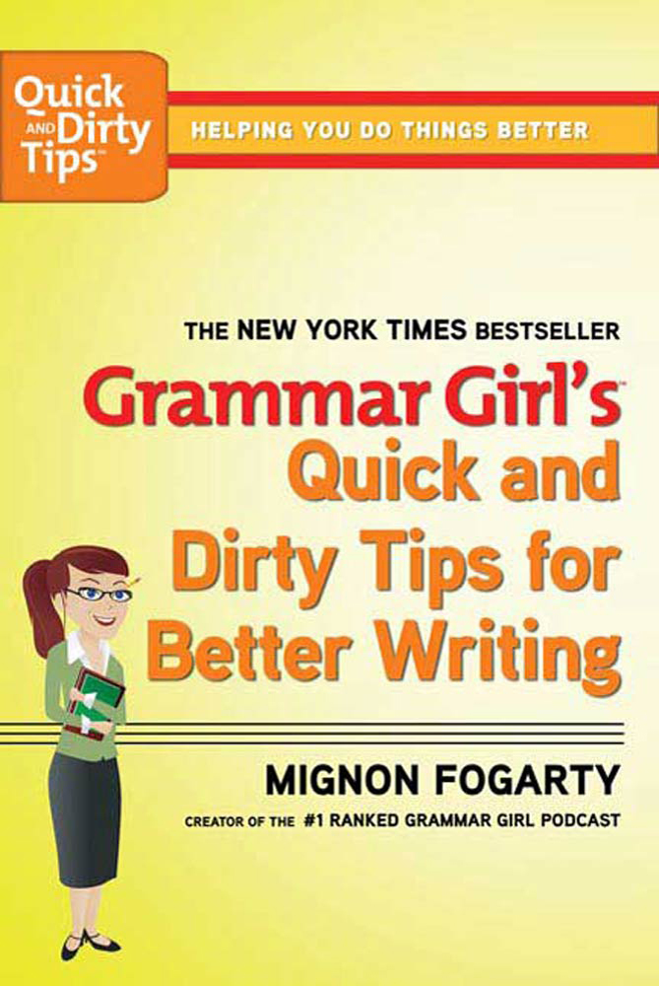
"Affect" versus "effect" is just one of the many confusing word choices that Mignon Fogarty covers in the "Dirty Words" chapter of her New York Times best-seller, Grammar Girl's Quick and Dirty Tips for Better Writing. You can download the chapter by clicking here.
You can order a copy of the paperback edition from any of these online retailers or pick one up at your favorite bookstore: Amazon; Barnes and Noble; Powell’s
The book is also available in an e-book edition. You can download a copy wherever e-books are sold.
- See more at: http://www.quickanddirtytips.com/education/grammar/affect-versus-effect?page=all#sthash.33x0ncQ4.dpuf

