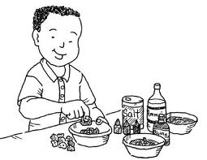Coal Flower Lab 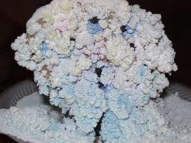
Introduction: Families and wives of coal miners in the late 1800’s and early 1900’s had little money to decorate or to buy toys, so they used things they had around the house to create these. Coal flowers were entertaining, and children liked to watch them grow because changes took place in a relatively short period of time. The original “coal flowers” were made without food coloring. Many people thought the flowers looked like snow, so they used then to decorate for Christmas. Also, they found that, in colder weather, the crystals grew slower and the colors were less vivid due to slower evaporation time. (Source Unknown).
Objective: To grow crystals on coal (or charcoal, sponge, or other substrate), and explain the relationship between temperature and crystal formation.
Safety:
1. Wear safety glasses for this experiment.
2. Do NOT use aluminum pans or paper plates for this experiment; use plastic, glass, or ceramic containers.
2. Wear plastic gloves and wash hands at end of lab.
3. Do not try to smell ammonia.
4. Take care not to get food coloring on your clothing and wipe any spills from the table.
5. Carefully dispose of “gardens” after observing- do not touch crystals! Sorry, you will not be able to
take this home.
Materials: Shallow bowl or plate, extra pan for spillover, thermometers, small pieces of coal, charcoal,
rock, or sponge, salt, ammonia, laundry bluing, food coloring, water, plastic cup or second
bowl for mixture, plastic spoons, safety goggles
For temperature experiment: a non-food freezer at 0 degrees C, incubator at 30 degrees C,
and room temperature (variable, but average 20 degrees C) could be used. Find a safe spot
where the bowls will not have to be moved.
Procedure:
1. In a shallow bowl or plate, place a few pieces of coal, charcoal, sponge, or rock.
2. In a separate bowl or cup, mix:
2 tbs. salt
2 tbs. laundry bluing
2 tbs. water
½ tbs. ammonia
3. Pour the mixture over the coal (etc.) mound.
4. Sprinkle dots of food coloring of your choice randomly over the mound.
5. Crystals will begin to form in several hours and “grow” for about a week.
6. If facilities are available, place dishes in locations with two or three different temperatures.
7. Record the start and stop time and temperatures in the experiment data sheet and observations.
Student Data Sheet

Name _________________________ Date __________________

Time/Date (Start) | Time/Date (End) | Temperature | Observations
Analysis:
1. Where in the individual dishes or plates did the crystals first appear? Try to explain a reason for this.
________________________________________________________________________________

2. How long (hours, days?) did it take crystals to appear at each location?
_________________________________________________________________________________

3. Did the crystals completely cover the coal or other substrate? __________________

4. What colors were most vivid? _____________________________________________________

5. What other items or variables might be used in this experiment?
________________________________________________________________________________

6. What effect do you think the surrounding temperatures had on the growing crystals?
_____________________________________________________________________________

7. Why do you think this was a natural activity for mining families in the late 1800’s and early 1900’s?
_______________________________________________________________________________
____________________________________________________________________________________
8. For extra credit, research on the Internet or at the library what causes the crystals to form.
____________________________________________________________________________________
____________________________________________________________________________________

