Two- Point Discrimination Experiment

How sensitive are you?

Is the back of your neck more sensitive than your fingertips? Is the skin on your elbow as sensitive as the skin on your forearms arms?

To find out, try this two-point discrimination experiment.

Background:

All over your body you have tiny touch and pressure sensors in your skin. These are called Meissner’s, Merkel’s, and Pacinian corpuscles. Some areas have many sensors, and others have relatively few. Areas where these sensors are packed are very sensitive to touch. This two-point discrimination experiment lets you discover which parts of your skin have many sensors, and where they are relatively sparse. The experiment involves gently pressing two sharp points onto a lab partner’s skin and asking them whether he/she can feel one or two pressure points.

In sensitive areas, the touch/pressure sensors are closer together, so the two tips of the paper clip will activate two separate pressure points. Messages from both sensors are sent to your brain and you feel both tips. In less sensitive areas, the touch/pressure sensors are further apart, so both tips activate only a single sensor. A message from this sensor is sent to your brain, and you only feel one tip on your skin. You can also compare the left and right sides of your body. It would be expected that both sides would have a similar number of receptors for the same body part tested. See if this can be verified after doing this experiment.

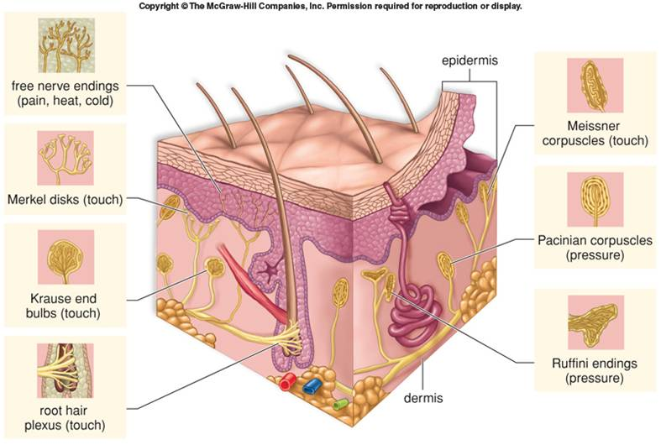

Materials:

For this experiment you will need:

A paperclip
A pen and paper
A centimeter/millimeter ruler
A lab partner

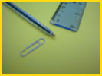

You can also try this on your own, with your eyes shut, concentrating on what you feel.

Procedure:

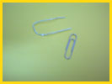

- Straighten a paper clip and bend it into the shape of a U. Make sure the tips are level with each other.

- Now, ask your partner to close his/her eyes. Arrange the ends of the paper clip so they are touching each other. (This will be 0 mm).

- Touch both ends of the paper clip gently (and at the same time) onto the tip of your partner’s right pointer finger and ask if he /she felt one pressure point or two.

- If your partner felt only one pressure point, spread the tips of the paper clip and try again. Write down the distance where he/she goes from feeling one pressure point, to feeling two pressure points.

- Do this for all of the areas listed on the Student Data Sheet. If there is enough time, switch places and have your lab partner determine your two point discrimination results.

- Complete questions on the Student Data Sheet and compare your results to those shown on the chart provided.

References:

Skin diagram. 2011. {Internet}. Google Images. New York: The McGraw-Hill Companies.

Your amazing brain at-Bristol, UK. How sensitive are you? {Internet}. {cited 16 Nov. 2011}.
Available at http://www.youramazingbrain.org/brainbody/sensitive.htm

Teacher Notes
Here are some representative Two- point thresholds from Marieb, Anatomy & Physology

Body Part | Two-point thresholds in the adult
Tip of tongue | 3 mm
Tip of index finger | 6 mm
Red part of lips | 8 mm
Edge of tongue | 12 mm
Palm | 15 mm
Forehead | 30 mm
Back of hand | 33 mm
Upper surface of foot | 40 mm
Back of neck | 57 mm
Back | 68 mm
Cheek | 6 mm
Nose | 7 mm
Forearm | 35 mm

