Master Eye
The eyes have it
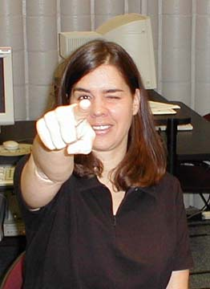
Point at a distant object with both eyes opened then close one eye to find your dominant eye.
Introduction
To perceive three dimensions, information from two eyes is important. However, for many people the information coming from one eye is given priority. This eye is then called their dominant eye. These tests will allow you to determine if you have a dominant eye, and, if so, which eye it is.
Materials
The Pointing method, no extra materials are needed
Variation 1 – Finger Circle (OK) method, no extra materials are needed
Variation 2- Bulls’s Eye method- use bull’s eye picture

Procedure and Observations:

The Pointing method:
- Stretch one arm in front of you and point at a distant object.

- (Note: People who do not have a dominant eye often have a hard time pointing because they see two fingers).

- Close your right eye; don't move your finger.

- Did your finger appear to "jump" where it was pointing when you closed your eye?

- Open both eyes and point again.

- This time close your left eye. (See image at top)

- If when you close an eye, the finger appears to jump in relation to the background, then the eye you closed is your dominant eye.

Results:
- Close your left eye and see a finger jump, you are left eye dominant.
- Close your right eye and see a finger jump, you are right eye dominant.
- See two fingers when you try to point, neither eye is strongly dominant.
- Repeat the above activities using the other arm to point, see if you get the same answer for your dominant eye.
Results: If you do, this is strong indication that you have a dominant eye.

Variation 1- Finger Circle (OK) method:
Make a circle with your index finger and thumb (the classic OK sign in America.)
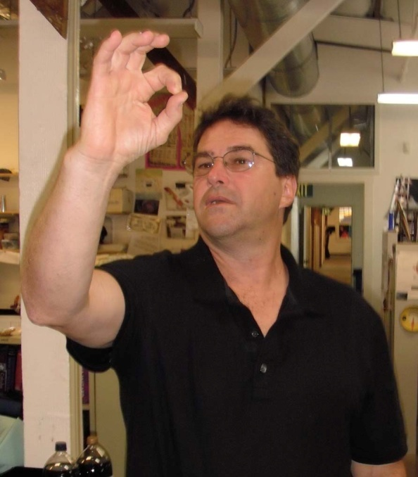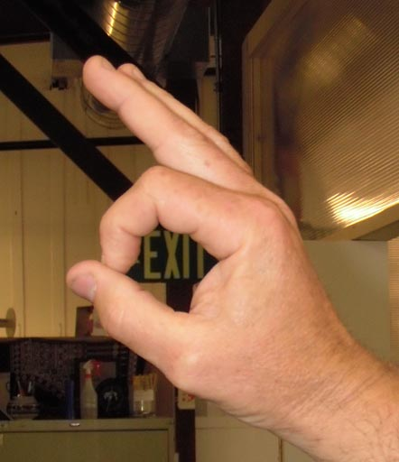
Hold your hand out as far as possible and circle a distant object, keep the object in the circle and bring your hand toward your face. If you have a dominant eye the circle will end up in front of that eye. To make sure you have a dominant eye, try the experiment with your other hand. If you get a different answer using different hands use the mirror method instead.

Variation 2- Bull’s Eye method:
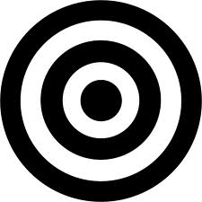
- This works better standing by your desk rather than seated.

- Bring both hand close together forming an open circle by crossing the pointer fingers and thumbs to form this figure.
- With both eyes open, stretch arms with the open circle you have made leading the way towards bull’s eye with your hands stopping about stopping about 6 inches above the bull’s eye.

- Keep both eyes open, keep staring at the bull’s eye, and slowly bring the circle made with your hands up to your face staring all the way. The open hand circle should end in front of your dominant eye.

* One of these 3 methods should work. There are some people who do NOT have a dominant eye, and if you have problems coming to a conclusion after trying these three activities that could be the case for you. Sometimes it takes practice and experience to perform these activities correctly.

References:

Master Aye. Retrieved 28 March 2913. Available at: http://www.exo.net/~pauld/summer_institute/summer_day1/perception/master_eye.html

